# INSTALLCONFIGUREAND RUNHADOOPAND HDFS

**Aim:**

Toinstallconfigureandrunhadoopandhdfs.

# Procedure:

## ToinstallJava

* 1. Checkifjavais available in thesystem

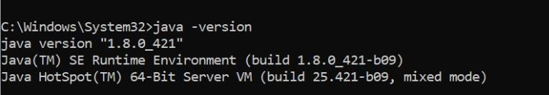

* 1. Ifnotinstall javajdk1.8andsettheenvironmentvariables

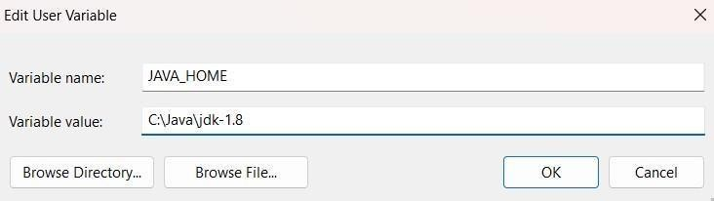

* 1. Setthepathvariable

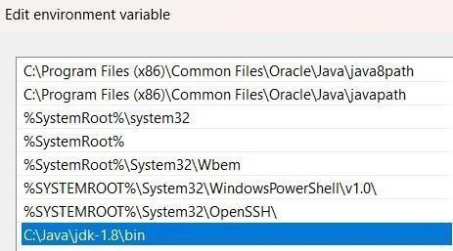

## HadoopInstallation

* 1. InstallHadoop3.3.6from<https://hadoop.apache.org/releases.html>



Downloadthebinary(checksumsignature)

* 1. Extractthejar filestoC://Hadoop

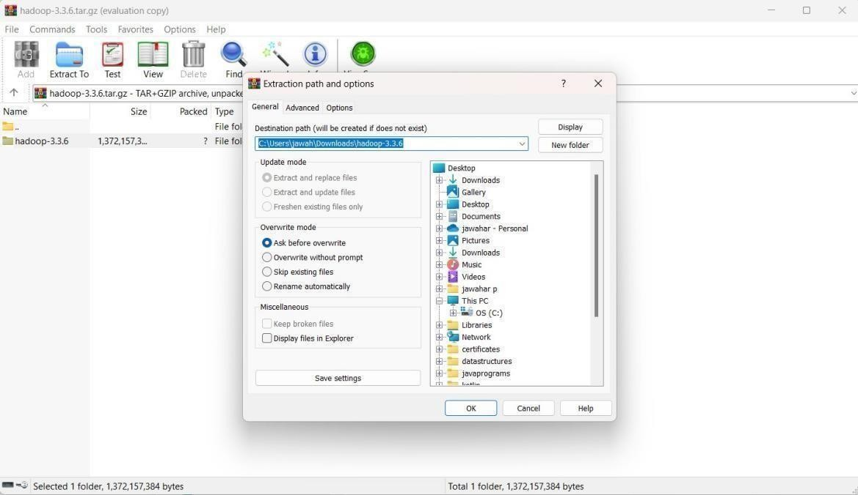

* 1. 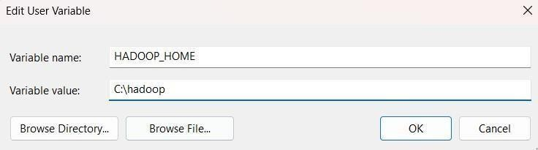Addenvironment variablesforHadoop

Addpathvariable

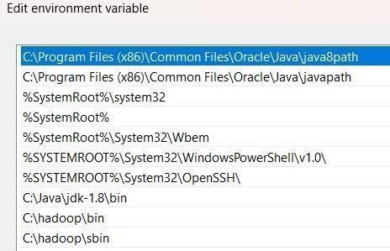

* 1. CheckifHadoopisinstalledsuccessfullyusingthecommandprompt

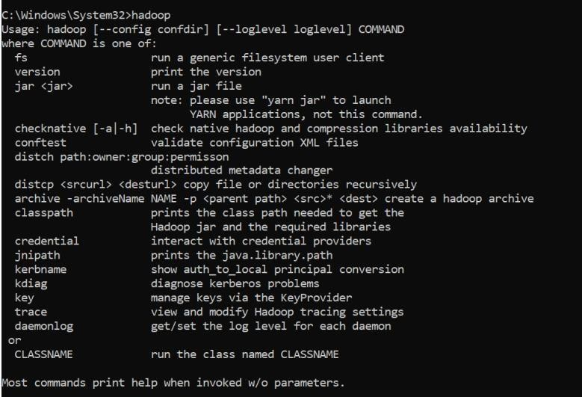

* 1. ThusHadoopisinstalledsuccessfully

## HadoopConfiguration

* 1. Configurecore-site.xmlinC:\hadoop\etc\hadoopbyadding

*<configuration>*

*<property>*

*<name>fs.defaultFS</name>*

*<value>hdfs://localhost:9000</value>*

*</property>*

*</configuration>*

* 1. Configurethehttpfs-site.xmlfileby addingthefollowing xmlcode

*<configuration>*

*<property>*

*<name>dfs.replication</name>*

*<value>1</value>*

*</property>*

*<property>*

*<name>dfs.namenode.name.dir</name>*

*<value>C:\hadoop\data\namenode</value>*

*</property>*

*<property>*

*<name>dfs.datanode.data.dir</name>*

*<value>C:\hadoop\data\datanode</value>*

*</property>*

*</configuration>*

1. Configuremapred-site.xmlfileby addingthefollowingxml code

*<configuration>*

*<property>*

*<name>mapreduce.framework.name</name>*

*<value>yarn</value>*

*</property>*

*</configuration>*

1. Configureyarn-site.xml filebyadding thefollowing xml code

*<configuration>*

*<property>*

*<name>yarn.nodemanager.aux-services</name>*

*<value>mapreduce_shuffle</value>*

*</property>*

*<property>*

*<name>yarn.nodemanager.aux-services.mapreduce.shuffle.class</name>*

*<value>org.apache.hadoop.mapred.ShuffleHandler</value></property>*

1. Changethebinshellcommand files.
2. Thushadoopisconfigured.

## Hadoop execution

* 1. Tocheckwhetherhadoopisrunningwemuststartthehadoop.Tostarthadoopwemustusethe command **start-all.cmd**

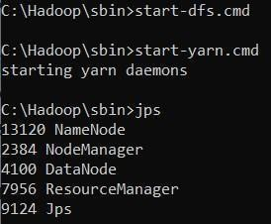

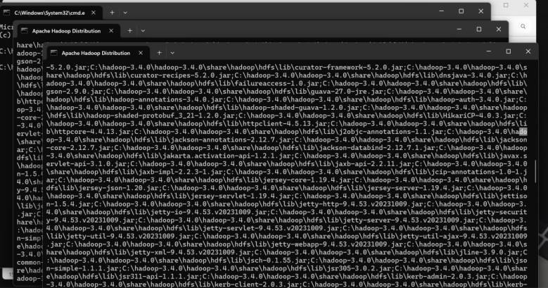

* 1. Checkifhadooprunsinlocalhost.

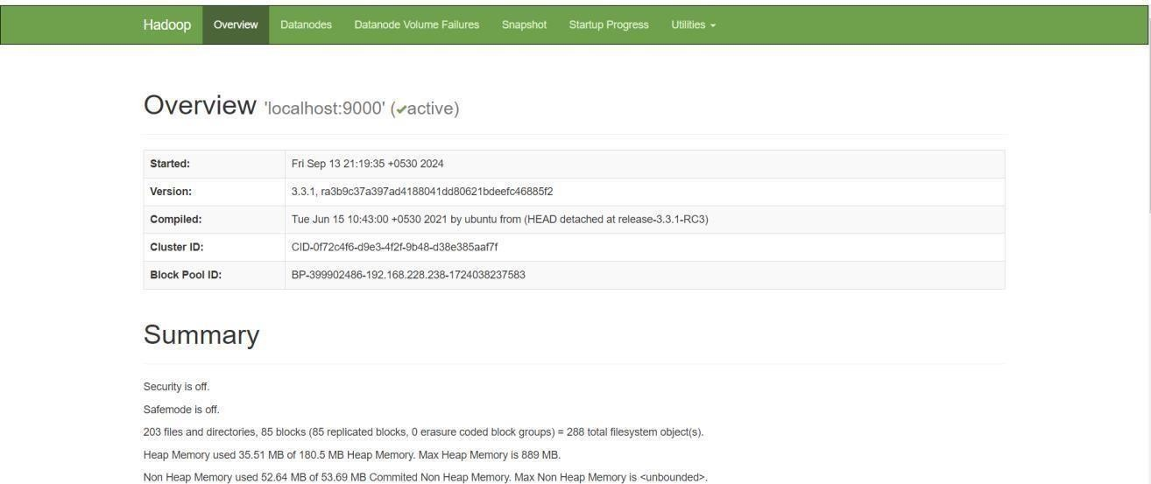Tocheckthisgotobrowserandtypelocalhost:9870

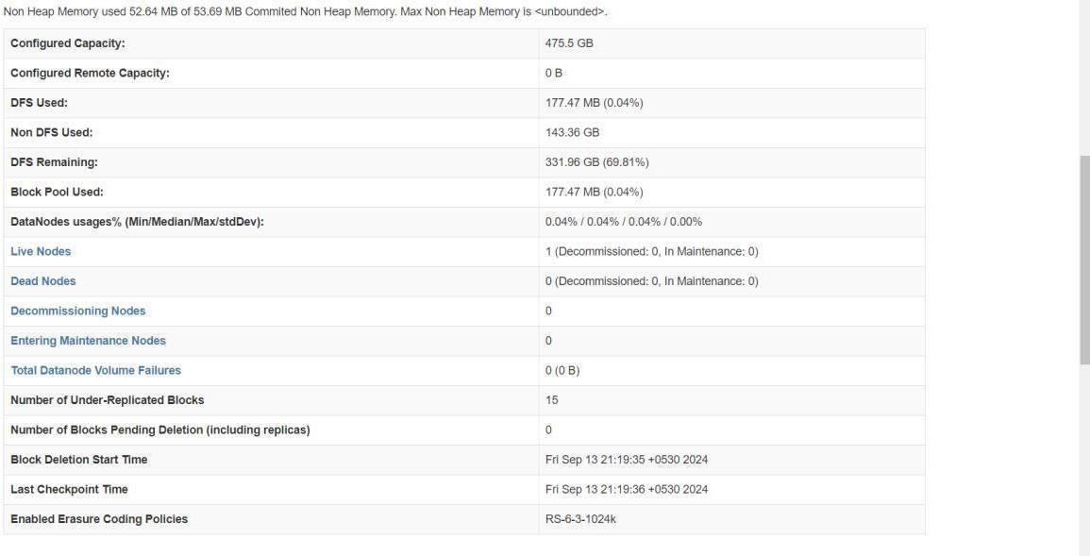

# Result:

Thushadoophasbeeninstalled,configured andrunsuccessfully.